Practical No 2
Aim: Using Packet Tracer, create a basic network of two computers using appropriate network wire through Static IP address allocation and verify connectivity

Theory:
We use the following network to verify the connectivity using Cisco packet tracer

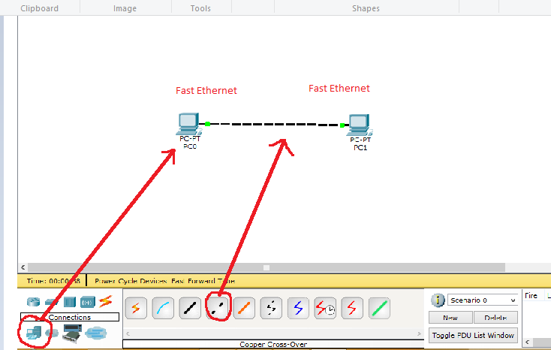

Now we set the ip address of the devices as follows

Host name | ip Address | Default  Gateway
PC0 | 192.168.1.2 | 192.168.1.1
PC1 | 192.168.1.3 | 192.168.1.1

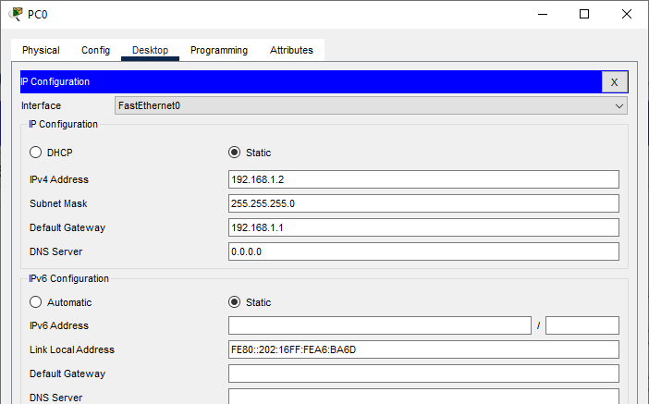

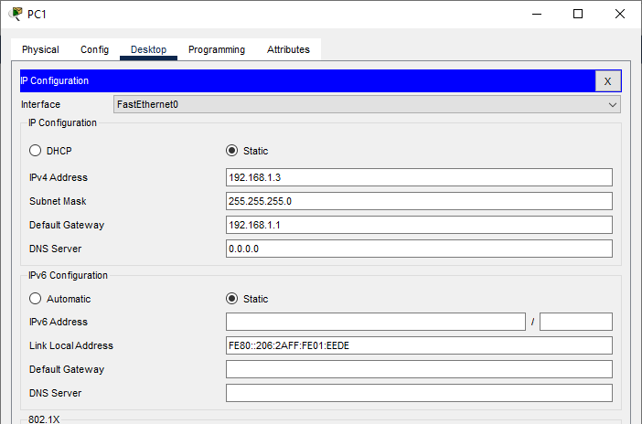

In order to check the connectivity we send a ping command from PC0 to PC1 as follows
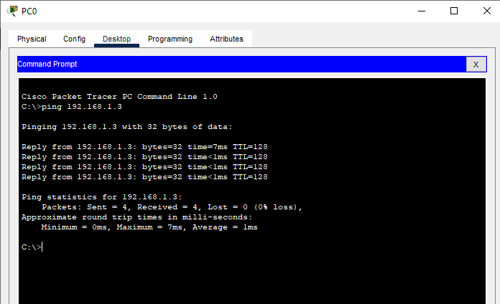

Result:
Hence the Connectivity between the PCs has been verified.

Link for the video demonstration of the practical:
https://youtu.be/yYYqDgM1XqQ

